***3D Printed Part Post Processing***

**Print List**

**2x Y-Axis Bearing Blocks**

**1x Gantry Flange**

**1x Gantry Flange - Motor**

**24x Bolt Spacers**

**2x Belt Tensioners**

**2x Belt Mount Idler (Optional)**

**2x Belt Mount Active (Optional)**

**1x X-Axis Bearing Mount**

**1x Torch Holder**

**1x Torch Clamp**

**4x Standoff**

**16x End Caps**

***NOTE: If you damage the threads on a 3d printed part they can be repaired by using brass threaded inserts. The link is an example of what can be used.***

<https://www.amazon.com/Hilitchi-Threaded-Embedment-Assortment-Projects/dp/B07VFZWWXY/ref=sr_1_4?gclid=Cj0KCQiAo-yfBhD_ARIsANr56g5ZLVRn0cwER9rngUpGf611IzU_-QyWnGM6HJqBKKL3l2UlOdYB0gYaAuQYEALw_wcB&hvadid=580876202520&hvdev=c&hvlocphy=9020758&hvnetw=g&hvqmt=e&hvrand=330495531328933387&hvtargid=kwd-247897830&hydadcr=952_1014986903&keywords=threaded+inserts&qid=1677438294&s=industrial&sr=1-4>

**Y-Axis Bearing Blocks**

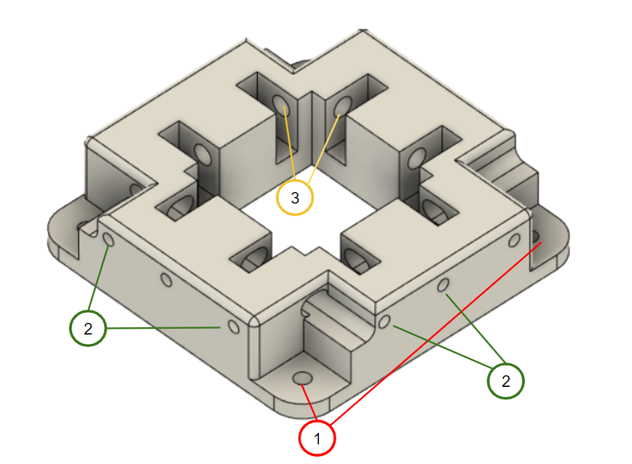

1 - Drill out all 4 holes with a 17/64” drill bit

2 - Tap holes all 8 with ¼” - 20 Tap

3 - Drill out holes with a 5/16” or 8mm drill bit, make sure you can insert bearing pins relatively easily.

**Gantry Flange and Gantry Flange - Motor**

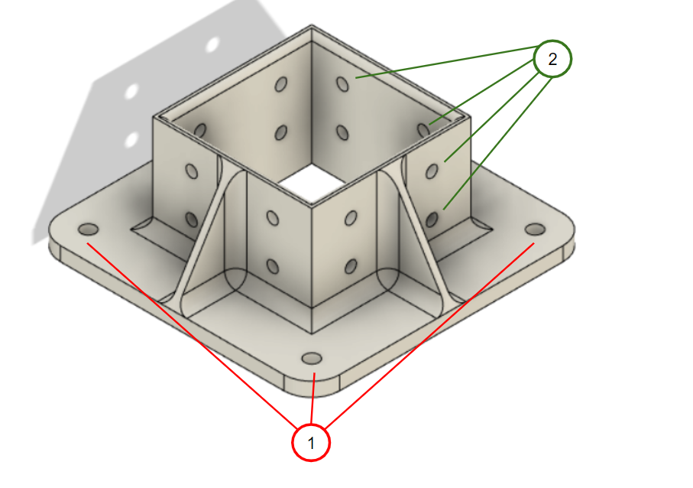

<https://www.youtube.com/watch?v=lhejn2-bwxc&list=PLWACT6mAqAyVz0Aqc3zoBX9DPsVudicCc&index=3>

1:30 - 5:00

1 - Drill out all 4 holes with 17/64” drill bit

2 - Drill out all 16 holes with 13/64” drill bit

**X-Axis Bearing Mount**

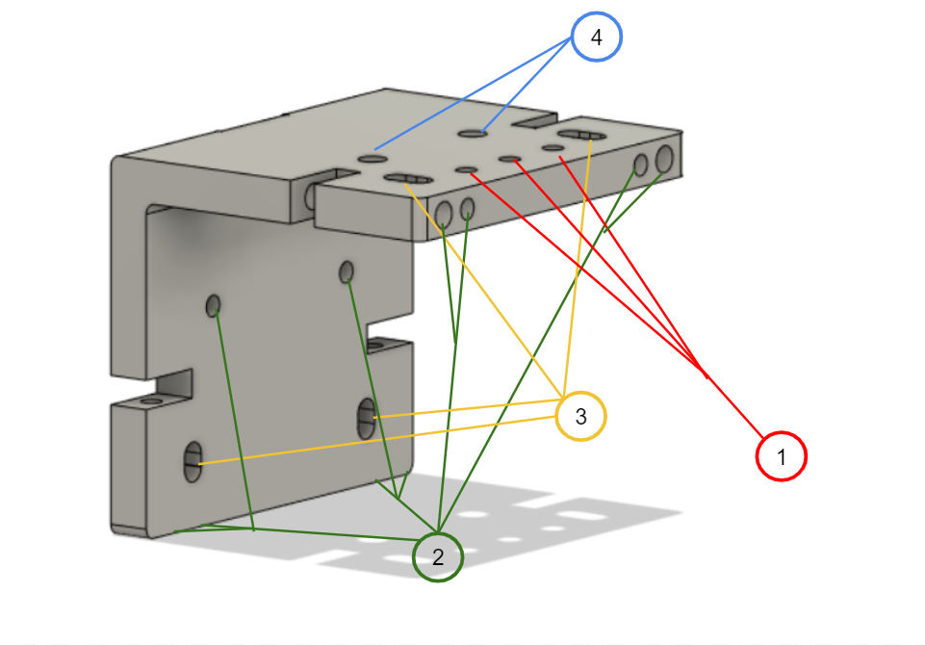

1 - Drill all three holes with 13/64” drill bit

2 - Drill and tap all 10 holes with 1/4” - 20 tap

3 - Make sure a ¼” bolt can move freely in 4 these holes

4 - Drill and tap both holes with 5/16 -18 tap

**PRO TIP:** On step number 4 attach the motor plate first and tap both at the same time so the threads align

**Belt Mount Idler and Belt Mount Active**

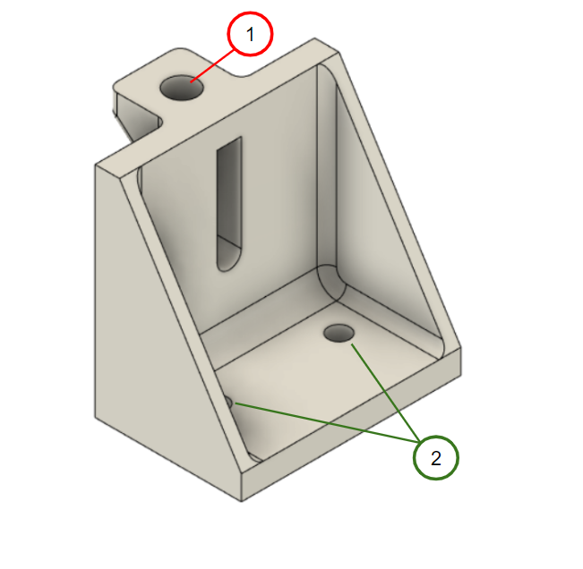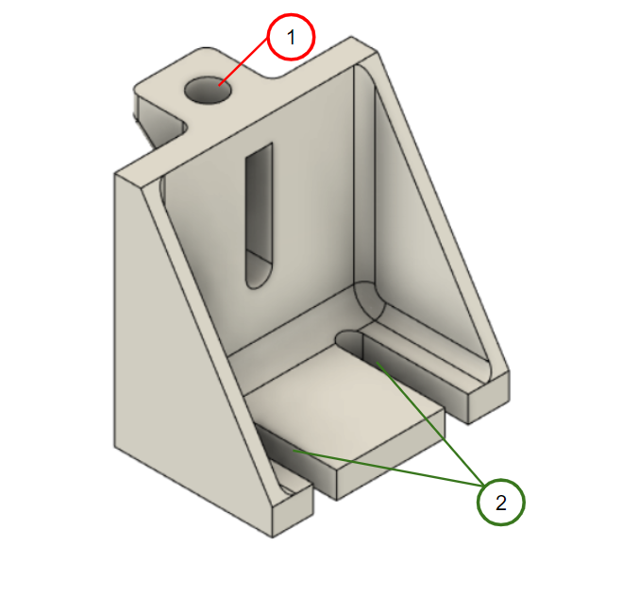

1 - Drill hole with 5/16” or 8mm drill bit

2 - Drill out holes with 13/64” drill bit and make sure a #10 screw move freely in slots

**Bolt Spacer**

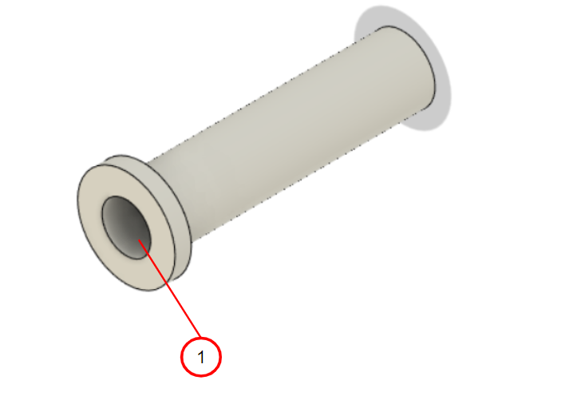

1 - Drill out hole with ⅜” drill bit

**Belt Tensioner**

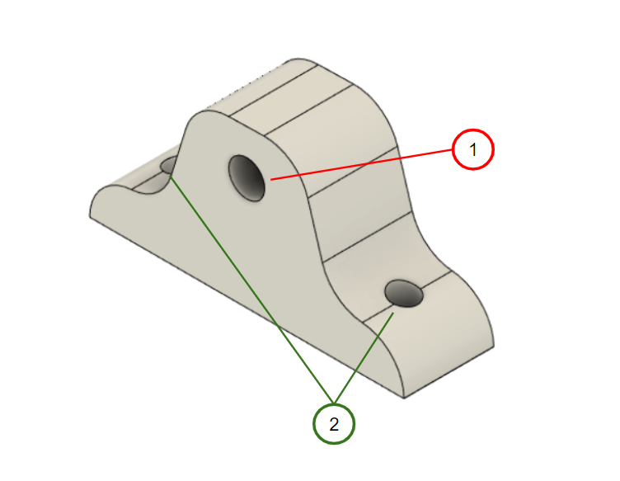

1 - Drill and tap hole with ¼”-20 Tap

2 - Drill out both holes with 13/64” drill bit

**Torch Holder**

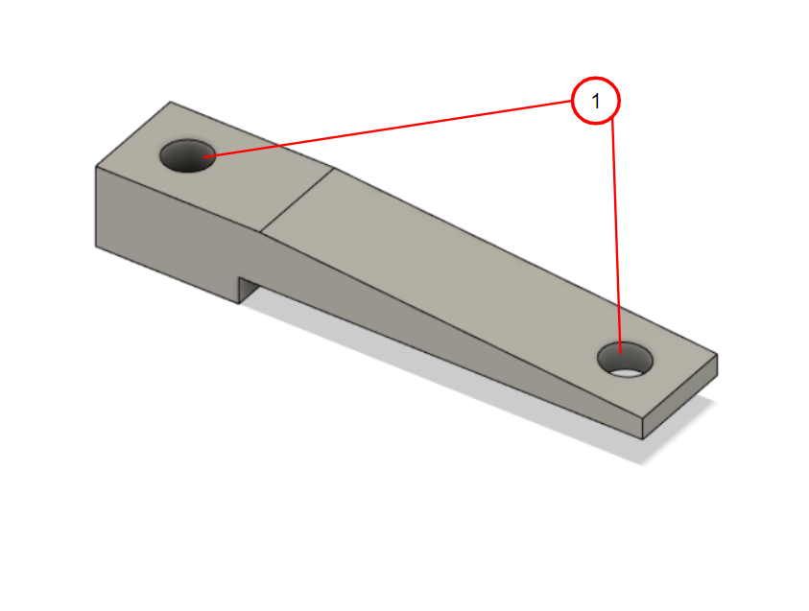

1 - Drill out both holes with 17/64” drill bit

**Torch Clamp**

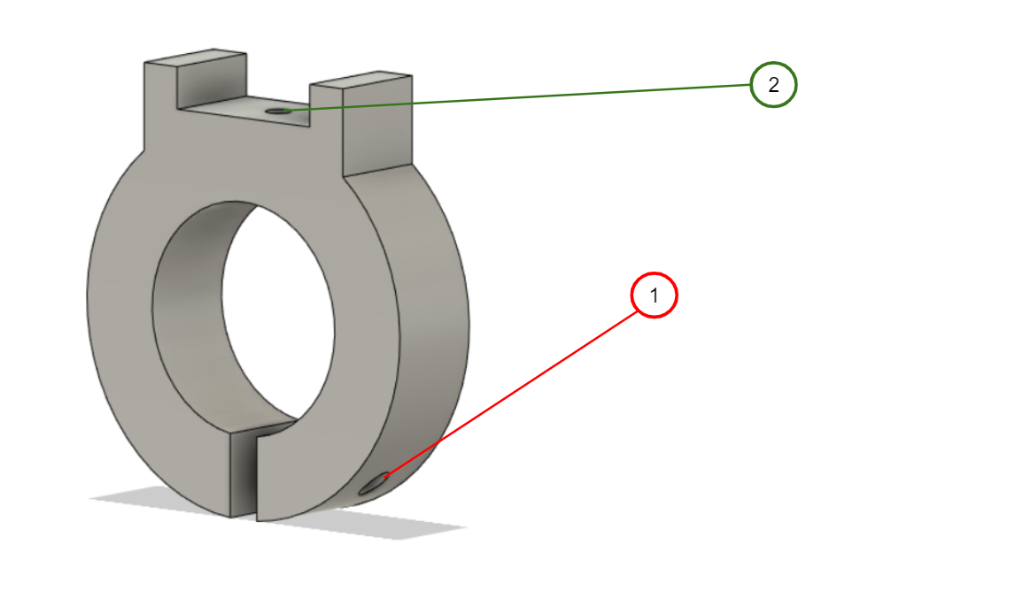

1 - Drill and tap with #10-32 tap

2 - Drill and tap with 1/4” - 20 tap

**Standoff**

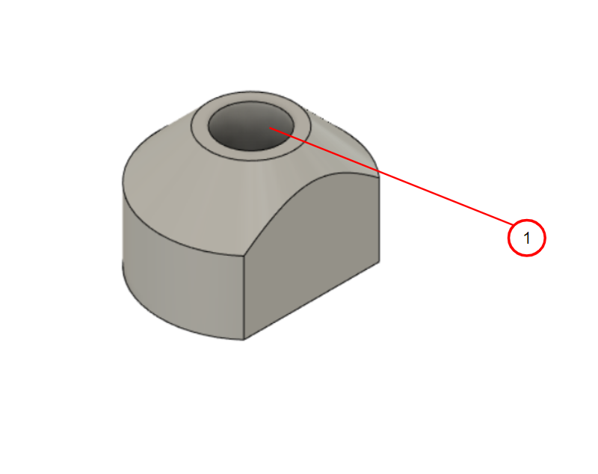

1 - Drill out hole with ¼” drill bit

**End Cap**

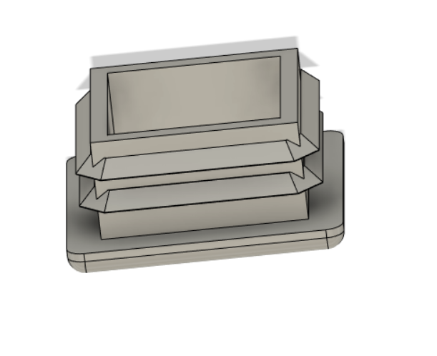

No post processing required